VEHICLE MANAGEMENT

**SMART INTERNZ**

SALESFORCE

SMART INTERNZ

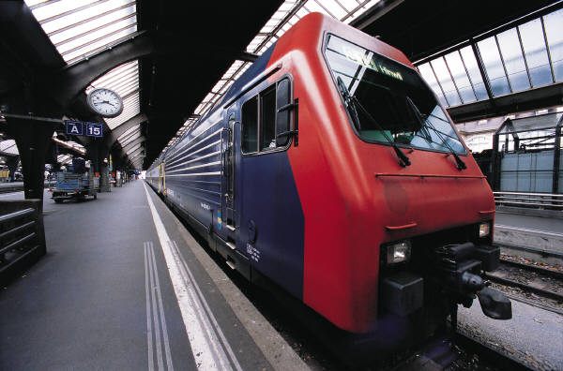T

Project Report

Introduction

* 1. Overview

A vehicle management system is a software web-based system that serves to manage commmercial fleets of vehicles and to ensure customers utilized safely,efficiently and professionally.

* 1. Purpose
* It is a software application which avoid more manual hours that needed to spend in record keeping and generating reports.

* This application keeps the data in centralized way which is available to all the users simultaneously.

2.Problem Definition And Design Thinking

2.1 Emphathy Map

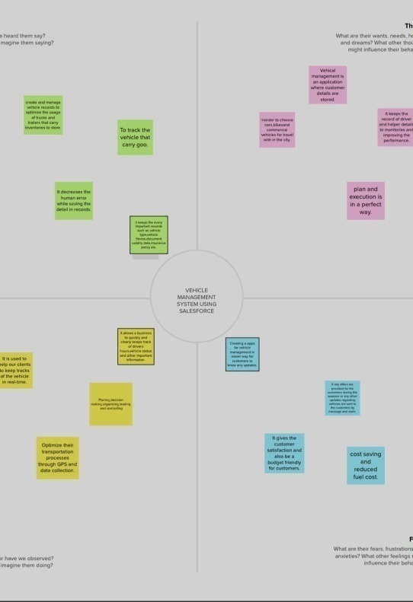

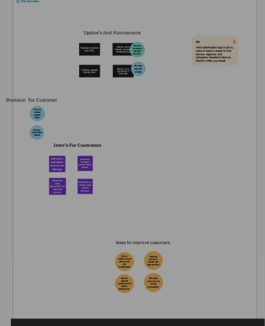2.2 Ideation & Brainstroming Map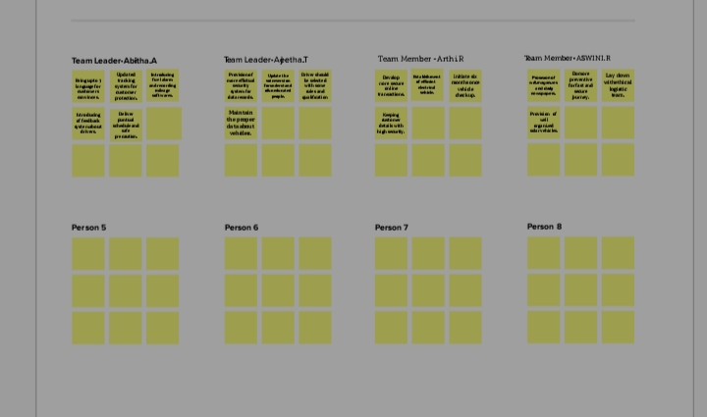

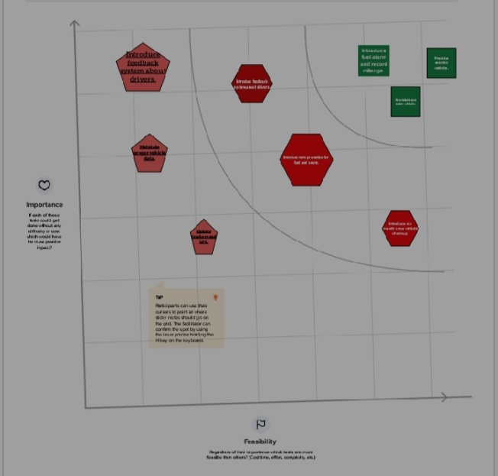

3.Result

# 3.1 Data Model

## 

|  |  |
| --- | --- |
| Object | Fields In The Object |
| 1. Vehicle | |  |  |  | | --- | --- | --- | | S No | Field Names | Data TYPE | | 1. | Customer Name | Text | | 2. | Customer MOBILE No | Number | | 3. | Vehicle Type   1. 2wheeler 2. 4wheeler | Picklist | | 4. | Vehicle Name | Text | | 5. | Vehicle No | Text | |
| 2.Driver | |  |  |  | | --- | --- | --- | | S No | Field | Data Type | | 1. | Driver Name | Text | | 2. | Licence No | Text | | 3. | Mobile No | Number | | 4. | Fair Per Hour | Text | | 5. | Vehicle | Lookup(Vehicle) | |

# 3.2 Activity & Screenshot

* Foremost we login into Salesfore Platform.
* After that we generate objects.In our project we have two objects.
* Vehicle
* Driver

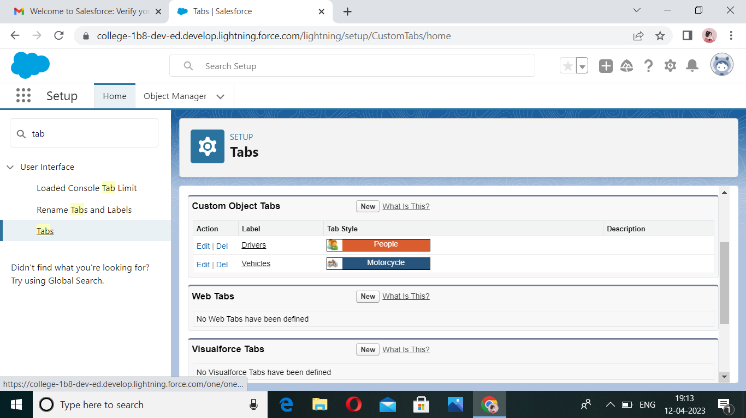

* And then we create “Field And Relationship”.

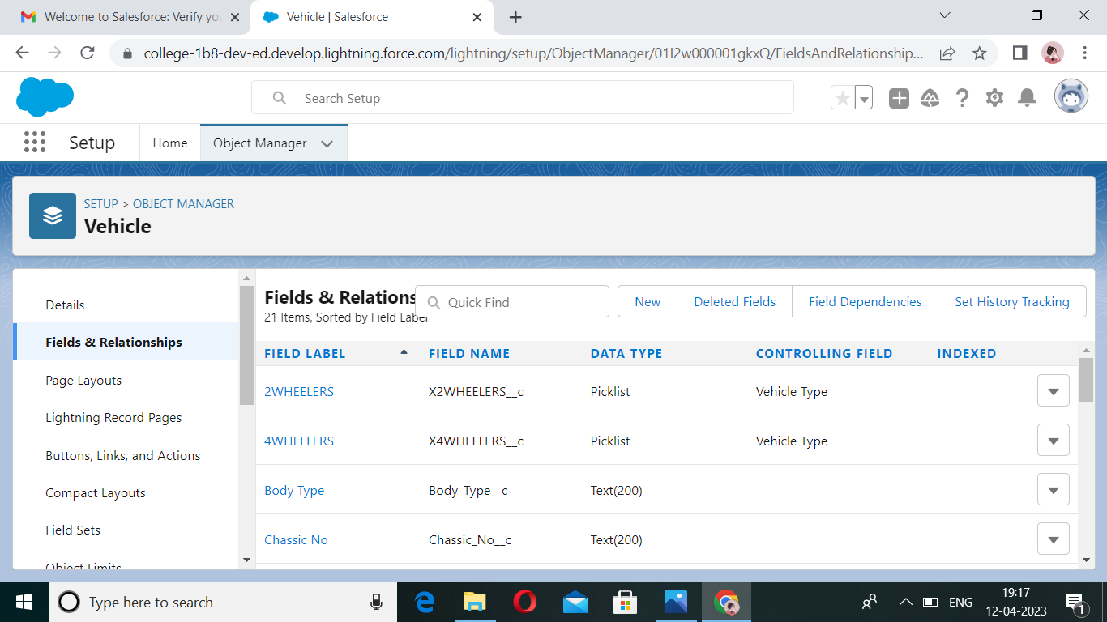

* On next step we generate ‘Lighting App’in milestone 4.
* Afterwards in milestone 5 we create “profile”. 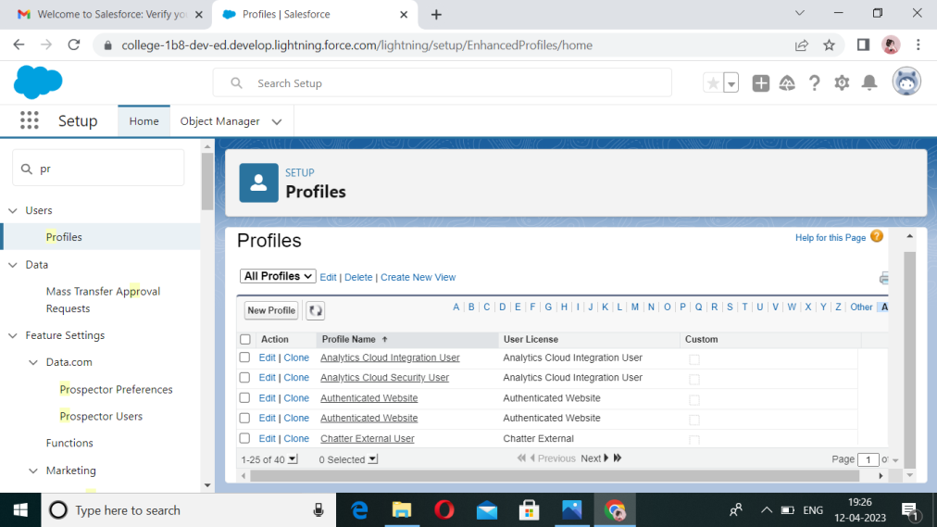

* After that we create “Users”on milestone 6.

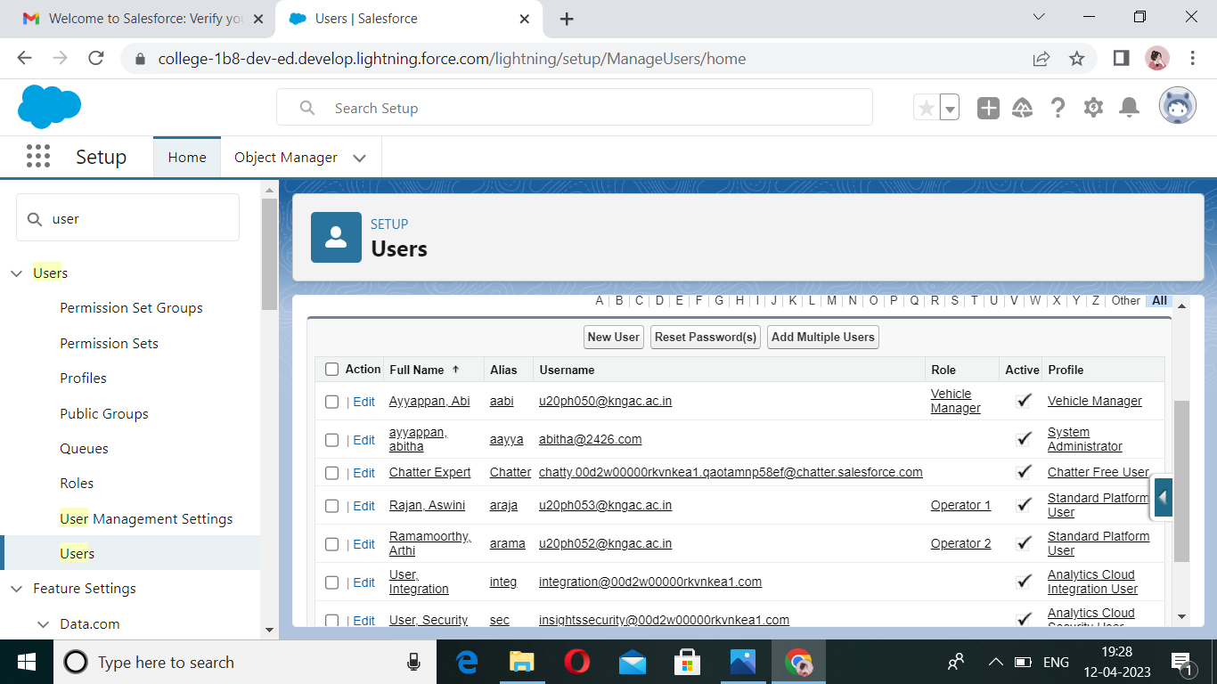

* Atlast we done our “REPORT AND DASHBOARD”.
* ‘Report And Dashboard for Vehicle.

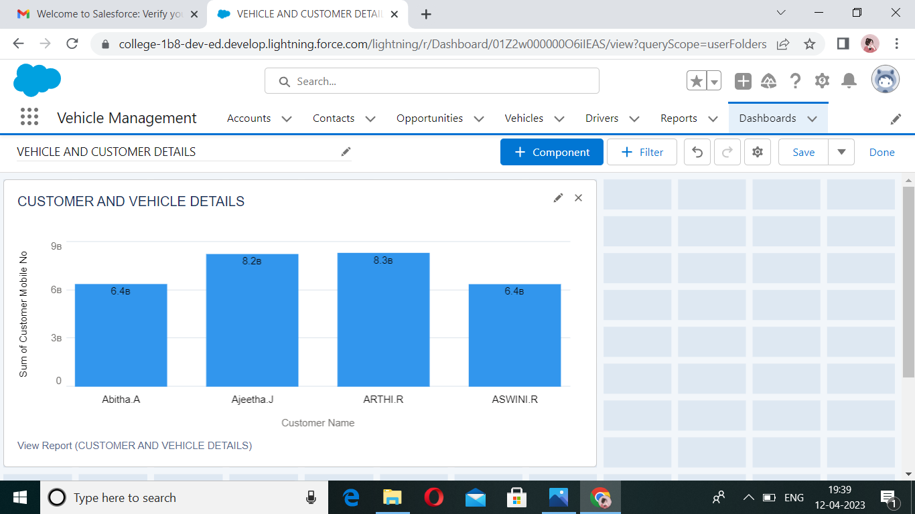

* ‘Report And Dashboard’ for Driver.

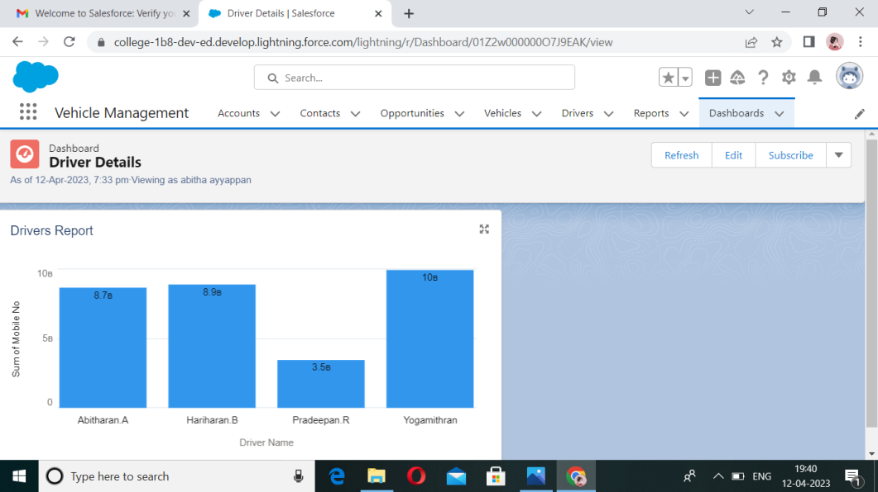

TRAILHEAD PROFILE PUBLIC URL:

* Team Leader -<https://trailblazer.me/id/a2020batch3>
* Abitha.A
* Team Member 1 -<https://trailblazer.me/id/a2020batch2>
* Ajeetha.T
* Team Member 2 -<https://trailblazer.me/id/a2020batch6>
* Arthi.R
* Team Member 3 -<https://trailblazer.me/id/a2020batch7>
* Aswini.R

5.Advantages

* Location wise user wise list can be configured.
* As vehicle information are already stored .So human error can be avoided.
* Customers and clients feels comfortable and friendly for contact.
* No duplication ensure accuracy of vehicle data.
* It is safety and secure because of vehicles contain GPS tracking system
* This process is more better than usual registeration process because it takes less time.

Disadvantages

* Active tracking based vehicle management requires monthly subscription charges anddata usage charges.
* It is difficult to manage and maintain vehicle management systemdue to use of multiple technologies such as cloud serves,cellular,wireless system,vehicle management software etc….
* GPS device used in vehicle management is power hungry which drains battery fasten.

# ....THANK YOU....